**CECS 545-50 Exercises 5.8, 5.21**

**Ryan Schron**

**Exercise 5.8**

a.

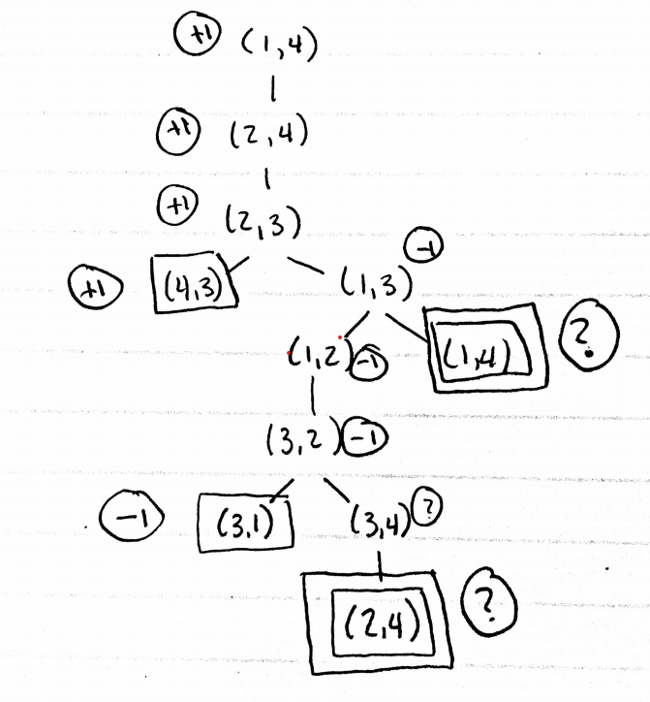

b. The “?” values were handled by giving preference to real state values that exist in the path, as a rational agent should choose to move towards a victory rather than loop in an undefined state.

c. MINIMAX would fail on this tree because it is a depth-first search technique and would enter an infinite loop. The algorithm could be modified to search for already discovered patterns, and just return winning value. That is, if it is entering a discovered loop, terminate and force the other branch that ends in a real value.

d. Winning the n-square game is determined by which player has the opportunity to skip a location by “jumping” over the other player. Assuming A moves first, it will always have the opportunity to jump over B on and even-node game board, requiring n-2 moves, whereas B will require n-1 moves to reach the other side. The same holds in reverse if the game board has an even number of locations. If B were to go first, the pattern would be reversed.

**Exercise 5.21**

1. True. Knowing the second player’s strategy is irrelevant for player 1, as it already knows the optimal strategy for player 2 and can adjust accordingly should the player not choose that path.
2. False. In this case the first player does not know the optimal strategy for player 2 and thus would benefit from understanding what choices player 2 intends to make.
3. False. Backgammon is stochastic so perfectly rational choices does not guarantee victory.